**Product Lifecyle Management**

PLM is an integral be part of the Enterprise Product Catalog. The EPC is a centralized master Catalog and would feed the different versions/ views of the Catalog to various systems in the OSS/ BSS landscape orchestrated through the PLM processes, viz. CRM, CC, Billing systems etc. As depicted in the figure above, EPC is the Master Catalog :

* + EPC / Catalog is the owner of all relevant data
  + Other OSS/BSS systems are fed by Central Catalog in a controlled manner (Publish/Launch mechanism of data distribution) and/or query interface where better suited.
  + Product, Service, Pricing data defined in Catalog and Launched to the target systems like CRM, Billing, OM etc.

1. Component Model
   * Catalog Designer :The Catalog Designer allows configuration of various aspects of catalog, including configuring catalog privileges, and importing and exporting catalog data. It also allows you to create new and open existing projects, add and remove products, services, and resources, set tax rates, make item associations, and much more
   * Product/ Service Catalog : This supports TMF’s definition of item types. The Catalog allows for modeling products, services, and resources as items in the catalog.
   * Product Lifecycle Manager/ Service Designer : Product Lifecycle Management module provides the functionality to manage the lifecycle of items (products, services, offers, resources, etc.) from conception, through design and development, to service and retirement. It integrates people, data, process and systems to provide a single view of items. PLM provides Web-based user interface and a configurable lifecycle workflow out of the box. PLM processes would be realized using the Service Designer. Service Designer provides an IntegratedDesign Environment (IDE) for the modeling of Telecom specific workflow in support of the PLM process.

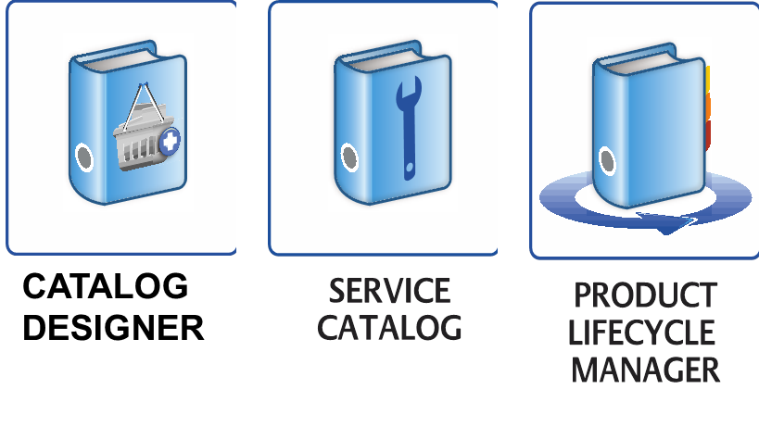

2 Process Model

The following sections of this document provide details on the PLM process model in order to provide an overview of process activities at various levels of detail. The sections also address the PLM elements required for the implementation of a PLM system in an organization. The topics addressed in the following sections are:

* Workflows
* Tasks in the different stages of the workflows
* Users/ Groups required to be configured to execute those tasks
* Accesses for the users in different stages of the various workflows
* Interaction of the PLM system with other system in the landscape

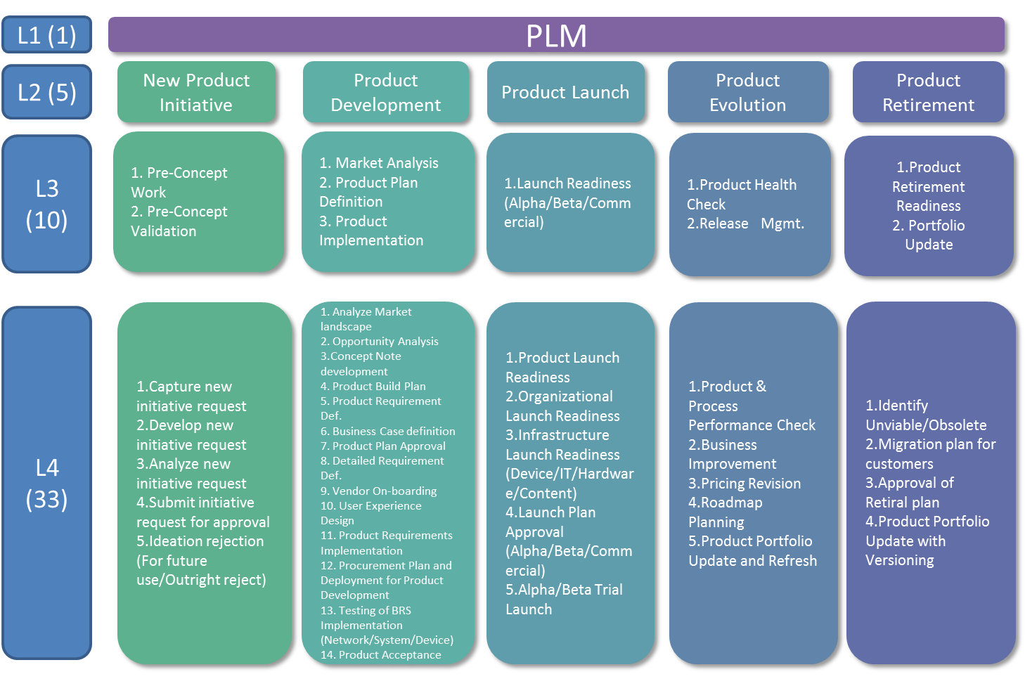

Figure 1: The PLM Process Model

3 Workflow Stages

The PLM workflow can be configured for each project to include six different stages. The product manager can configure the change request through a user interface to implement all stages or just one stage of the workflow process. These stages include:

Conception

Evaluation

Definition

Build

Testing

Launch Product

**3.1 Conception**

The Conception stage is the first step in the PLM process that outlines the business case for the change request.

The marketing and finance departments define the business case for implementing a product change or a new product launch. The IT and Support departments are involved in this stage to analyze the feasibility of the change. The workflow process sends a create change request to the Product Manager user. A product manager is assigned to the change request and once that product manager has approved the request, three change requests are sent in parallel to the Pricing and Economics, IT/Support, and Marketing Manager users (for example, users with the associated privileges). Once all the work has been started and completed on the three tasks, then an approval task is sent to the user defined in the project change request configuration.

**3.2 Evaluation**

In the Evaluation stage, the business analyst and IT departments develop and confirm business requirements.

A create task is created for the business analyst to create the business requirements documentation. Once the business analyst has completed this task, the workflow engine sends a task to the IT department to review the requirements. Upon completion of the requirements review, the users defined in the project configuration are required to approve.

**3.3 Definition**

In the Definition stage, the product details and rollout plan are defined.

A task is sent to the Product Manager to create a project plan. Once the project plan is completed, the product modeller receives a task to define or design the product. Lastly, the users defined in the project configuration will be sent an approval task to approve the rollout plan and product definition.

**3.4 Build**

During the build stage, the product is built in the system.

The IT department is sent a task to start the technical configuration and once completed, a task is sent to the Product Modeler to configure the product in the system. The approver defined in the project configuration approves the built product.

**3.5 Testing**

In the testing stage, the product is released to testing.

The workflow sends the first task to the Product Manager to release the product for testing. Once testing begins, three simultaneous tasks are sent to IT, Network Operations and Marketing Managers for testing. Once all three departments have completed their testing tasks, an approval task is sent to the users defined in the project configuration for this stage.

**3.6 Launch Product**

The last stage of the product lifecycle is to execute the rollout plan and launch the product.

A task is sent to the Product Manager to execute the rollout plan. Once the Product Manager has completed the task, two simultaneous tasks are sent to the IT and Network Operations departments to launch the product. Once those two departments have completed their tasks, an approval task is sent to the users defined in the project configuration for the launch product stage.